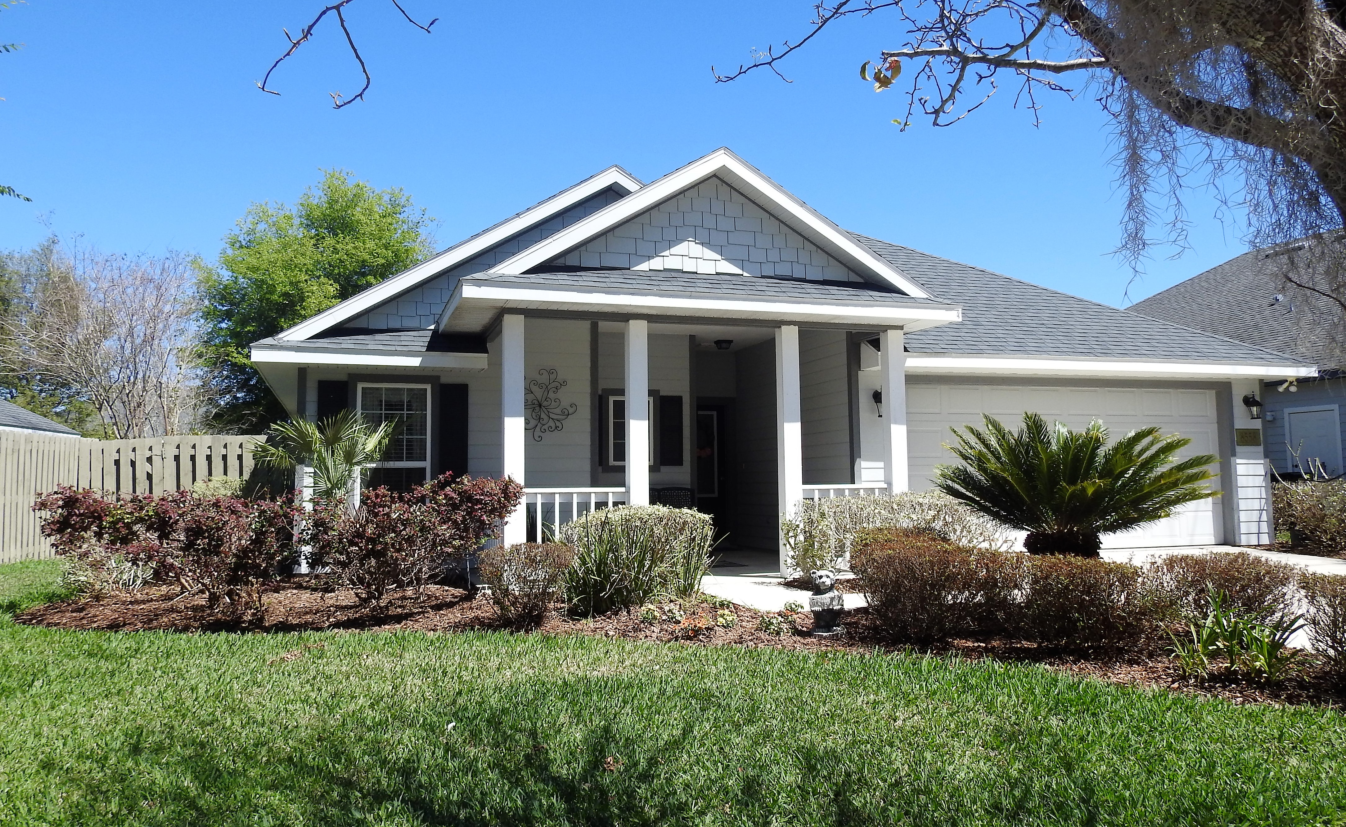  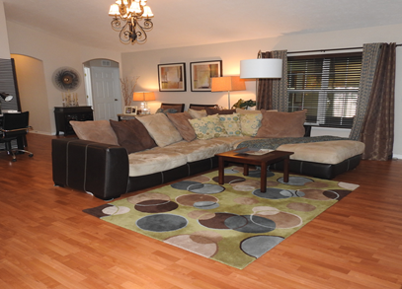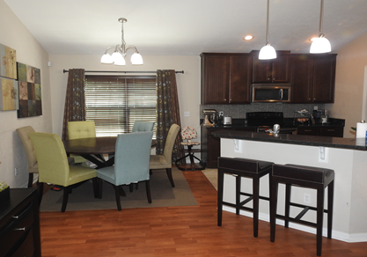  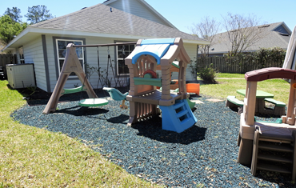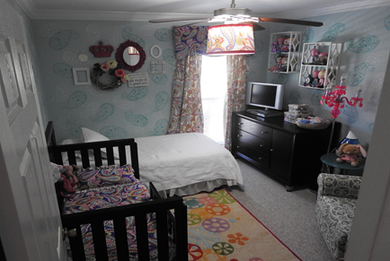  HOUSE FOR SALE  8558 sw 80TH PL  GAINESVILLE, FL 32608  $ 244, 990  LONGLEAF VILLAGE  - Impeccable starter home with a bunch of upgrades in a peaceful and much sought-after neighborhood.  - 3 bedrooms/ 2 bathrooms/ 2-car garage  - 1,504 sq. ft. of heated/cooled space.  - Home built in 2007 by eco-friendly builder, Tommy Williams  - Vaulted ceiling in the great room  - Crown molding in all bedrooms and bathrooms  - Jet-tub in master’s bathroom and his/her walk-in closets  - Wood laminate flooring in great room, Berber carpets in bedrooms, & tile in the kitchen and bathrooms  - 8 miles to UF Health Shands & VA  - Close to shopping outlets & restaurants(Celebration Pointe & Butler Plaza) | Stainless steel appliances, back splash, & granite countertop in the kitchen  ────  Enclosed back porch [day room] (glass/aluminum)  ────  Fenced backyard (gazebo & kids playsets included with rubber mulch)  ────  Wood blinds in all bedrooms, living room and kitchen; honeycomb and enclosed blinds in the day room  ────  Pre-wired for surround sound & alarm system  interested parties, please contact:  Duke – (352) 870-8824  Millie – (352) 226-2212

