Townhome for rent/sale
BEAUTIFUL 2-STORY, END-UNIT CONDO AVAILABLE CLOSE TO BUTLER PLAZA, UF & SHANDS!
(like 15 minutes door to team room, including walk from resident parking!)
-2-Story floorplan means nobody above or below you
-End unit provides extra living room space as well as extra light!
-Both bedrooms upstairs have their own bathroom and spacious closets
-Use the downstairs room as either an office or a 3rd bedroom!
-Beautiful kitchen area with granite counter-tops, wood cabinets and an under-mounted sink
-All appliances included, including washer and dryer.
-Concrete block between every unit creates a great sound barrier- very quiet
-Community features include a sparkling swimming pool, green areas, bus routes to UF and Shands.
-Neighbors are health science students, young professionals.

Please contact: Daphy@peds.ufl.edu with interest

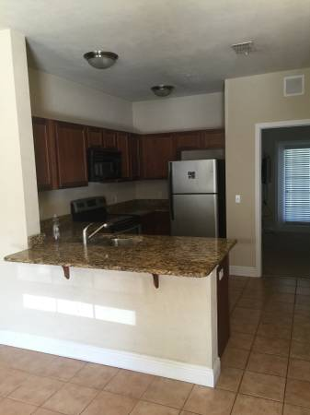
Living Room into kitchen, into downstairs den/ 3rd bedroom

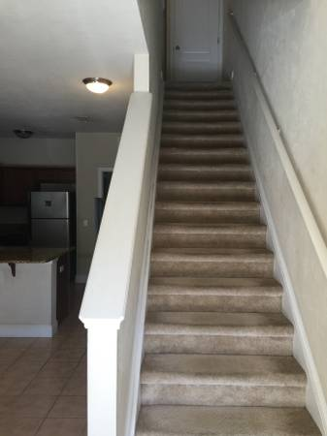
Stairs

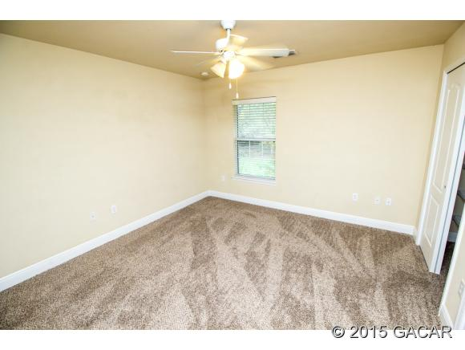
Master bedroom
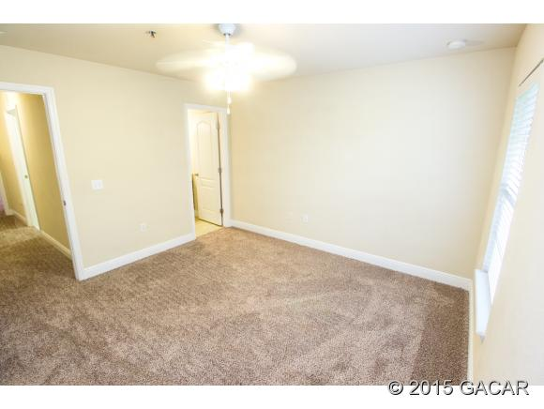
Master bed and bath into hallway
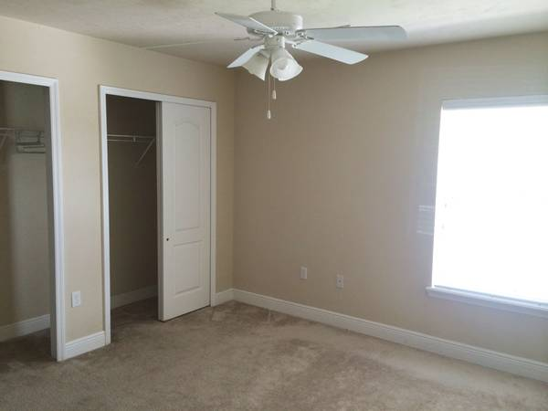
master bedroom with double closet (also has a bathroom)
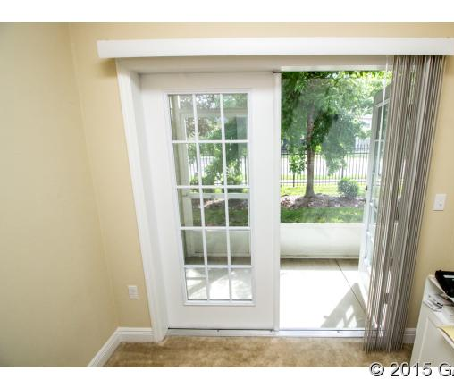
Den/ 3rd bedroom with bath into patio

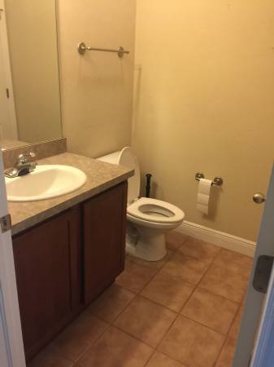
downstairs bathroom
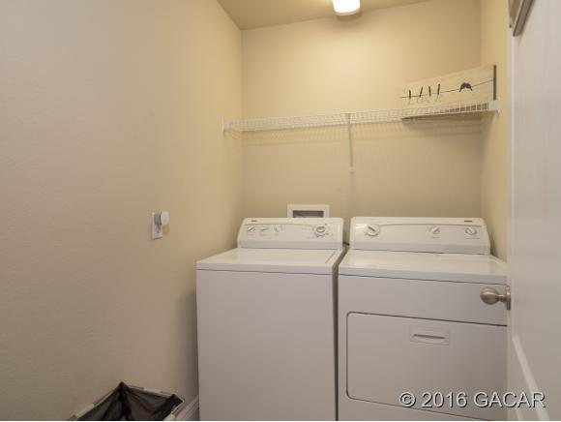
Spacious laundry room with space for hanging rack/ shelving unit

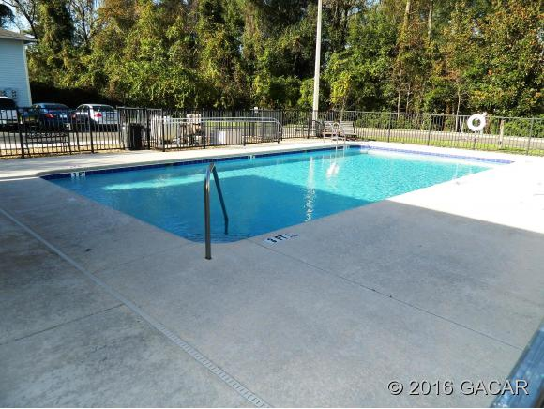
Pool with bathroom and charcoal grills

