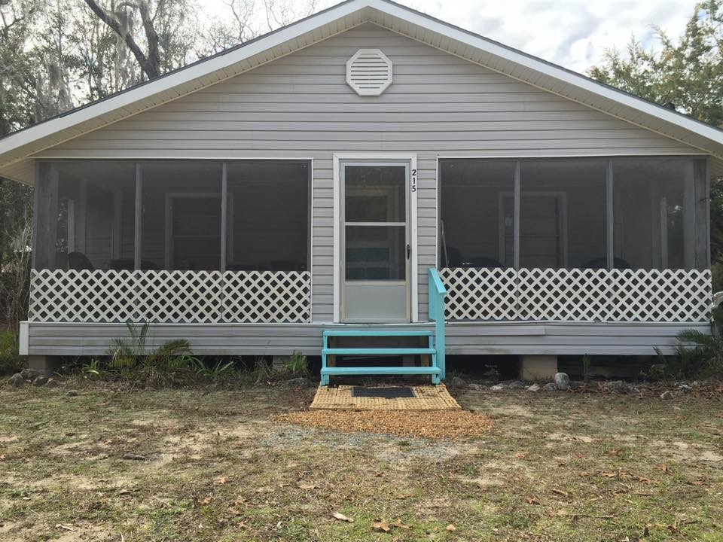

Steinhatchee “Safe House” for Sale

https://www.facebook.com/pg/Steinhatcheesafehouse/reviews/?ref=page_internal

2 bedrooms/1 bathroom

1 BR – king bed/1 BR – queen bed

Living Room with sofa bed, daybed, 2 chairs coffee table and 2 end tables; 48’ HD TV;

Eat-in kitchen with custom benches; dishwasher, stove and refrigerator and all kitchen supplies. Bathroom has double stack washer and dryer combo, whirlpool bathtub and shower. Screened porch with table and chairs/covered back porch and fire ring for bonfires.

Approximately, 1 mile from Sea Hag Marina and boat ramp. Sleeps 9 comfortably.

Good rental property or weekend retreat.

**Call Mike at (386) 546-5288 for more information. $69,900**

