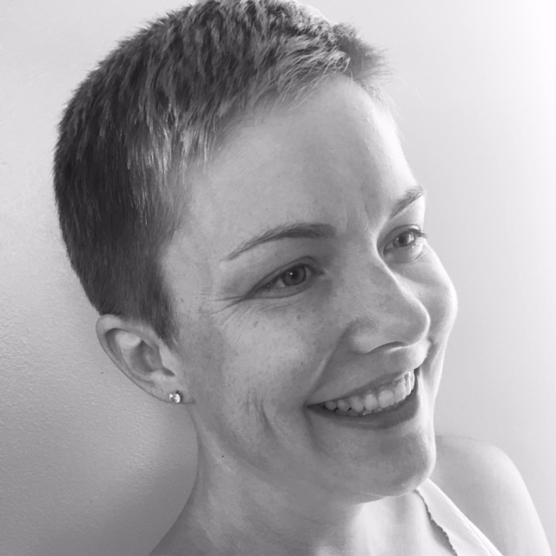 |  | Jeremie Wicks  - Sola Salon Studios  Studio 18  490 NW 60th Street Gainesville, FL 32605

Your Gainesville connection

Hi! My name is Jeremie Wicks and I was born and raised in Gainesville. I am a salon owner within Sola Salon Studios in Northwest Gainesville.
I have more than 10 years of experience in the beauty industry and have been working as a licensed hair stylist for 8 years. I specialize in corrective color and precision haircutting. You can find my portfolio work on Instagram and Facebook.
I have an amazing booking system that allows online booking, accessible 24 hours a day, for your convenience. There you will find a list of services, prices and other general information. I look forward to meeting you and providing all your haircare needs.
I am always reachable via phone, text, email, Facebook messenger and the like. I offer free consultations as well so never hesitate to reach out!

Below are links for online booking, portfolio work and more general information.

jeremiewicks.glossgenius.com

Facebook.com/jeremiewickshair

Instagram: JeremieWicksHair

