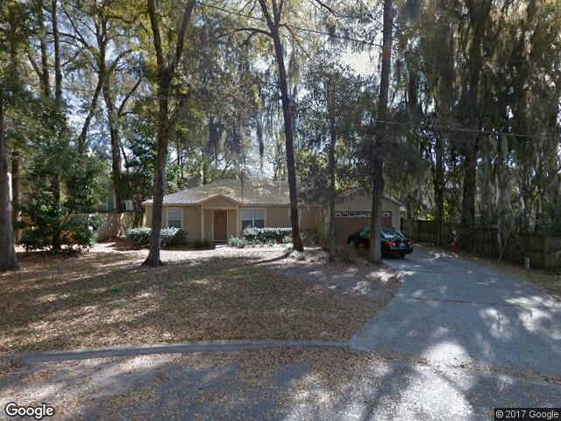

Looking for a male or female roommate (who doesn't mind sharing a bathroom with a male) for June 1-June of 2018. My brother and I are renting a 3/2 house located off Newberry road, across from Gainesville health & fitness center. I am a nurse at Shands in the PICU. My brother is in nursing school and works at the hospital on the weekends, so we're looking for someone quiet and easy to get along with! The house has a 2 car garage, fenced in backyard with a screened in patio. W/D, fairly new carpet, new dishwasher.
Rent is $425 not including utilities which usually average $80-$120 each person.
House address is 515 nw 51st st

Feel free to call or text me, I will send additional photos.
Shelby 352-870-5604

