8115 SW 65th Lane
Gainesville, FL 32608 $225,000

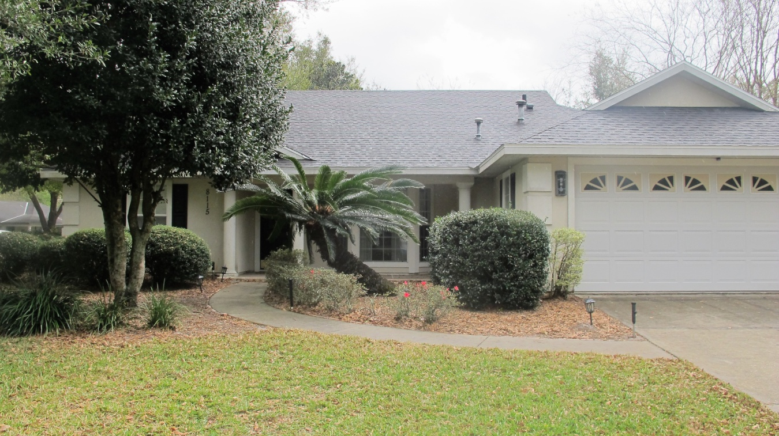

Bright & open floor plan with lots of natural light in Mentone! Convenient access to UF and Shands – popular neighborhood for residents. 1579 sq ft split 3 bed 2 bath. Brand new 30 year arch roof & landscaping, new interior painting, plus newer water heater & kitchen appliances. Dramatic great room includes fireplace with wood laminate flooring & French doors leading to patio. New sod in large fenced-in backyard plus two patios create rare outdoor retreat. Open kitchen with breakfast nook & access to screened in lanai. Master bedroom with vaulted ceiling & walk-in closet, plus access to lanai. Luxury bath with tub & separate shower & double vanities. Inside laundry, washer and dryer included. Ample storage throughout. Mentone amenities include pool, playground, volleyball, basketball and tennis court, plus walking trail.

If interested contact Emily Custer: emcuster84@gmail.com or 913.707.3393

